# **Summary:**

GOOOAL Bets is a premier soccer betting website known for its precise lines and exotic prop bets. GOOOAL Bets also offers analytics services for entitled users. In order to have an edge over the competition, GOOAL Bets is looking to implement its own in-house database. Implementing this database will allow them to own an almanac of statistical resources leading to more precise and insightful betting opportunities for their customers.

# **Stakeholders:**

The stakeholders included in this database implementation project include; the CEO, board of directors, all employees, and any customers who are either placing bets or using the analytical services. The CEO and board of directors are hoping that this project will lead to increased profits due to the precise lines and added variety of bets the database will allow them to offer. Employees will have an easier time creating betting opportunities for customers due to the easily accessible data. Customers will enjoy a wider variety of bets, and more accurate analytical services.

# **Business Rules:**

* A player can only play one position
* A player can play for multiple teams during a season
* A team has many players
* A team can only have one coach
* A coach can only coach one team
* A team can only be from one city
* A team can only have one record
* Two teams play per match

# **Glossary:**

**Player -** An individual taking part in a soccer match.

**Team -** A group of Players forming one side in a soccer match.

**Position-** The joint arrangement of a Team on its field of play during a game and to the standardized place of any individual Player in that arrangement.

**Coach-** A person who teaches or trains a Player.

**City-** A location where a Team is from.

**Match-** A contest in which Teams compete against each other.

**Captain-** The player who leads the Team.

# **Data Questions:**

**Data Questions:**

1. Q: What is the total amount of players by position?

A: Defense 3, Forward 4, Goalie, 2 , Midfield 3

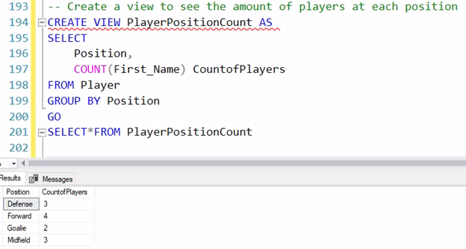

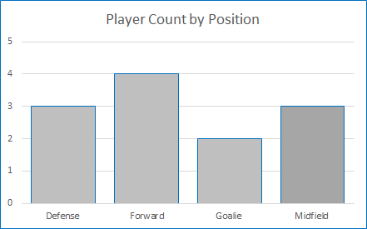

1. Q: How many teams does each city have associated with them?

A: Each City has 1 team associated with them

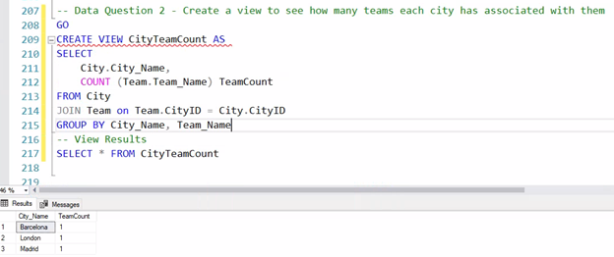

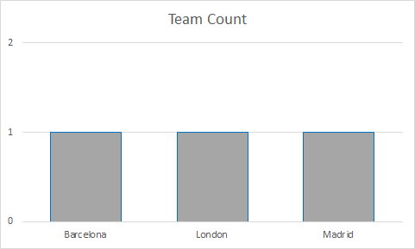

1. Q: What is the roster Count for all teams?

A: Barcelona 4, Chelsea 6 , Real_Madrid 5

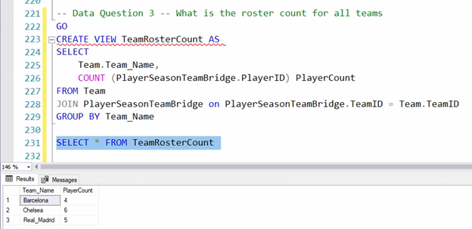

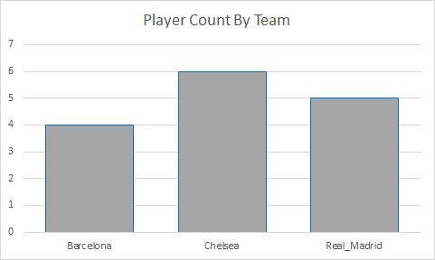

1. Q: How many wins does each team have at home

A: Barcelona 2, Chelsea 1, Real_Madrid 0

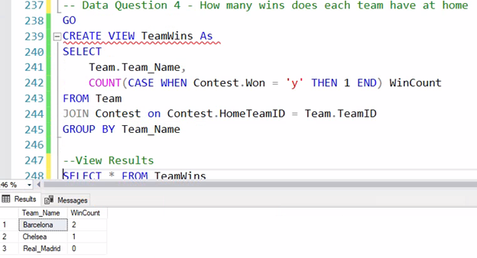

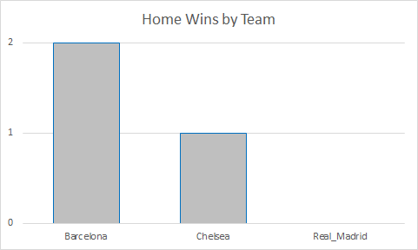

1. Q: How many players were captains in season 1 versus players that were not captains in season 1

A: 3 players were captains in season 1, 9 players were not captains in season 1

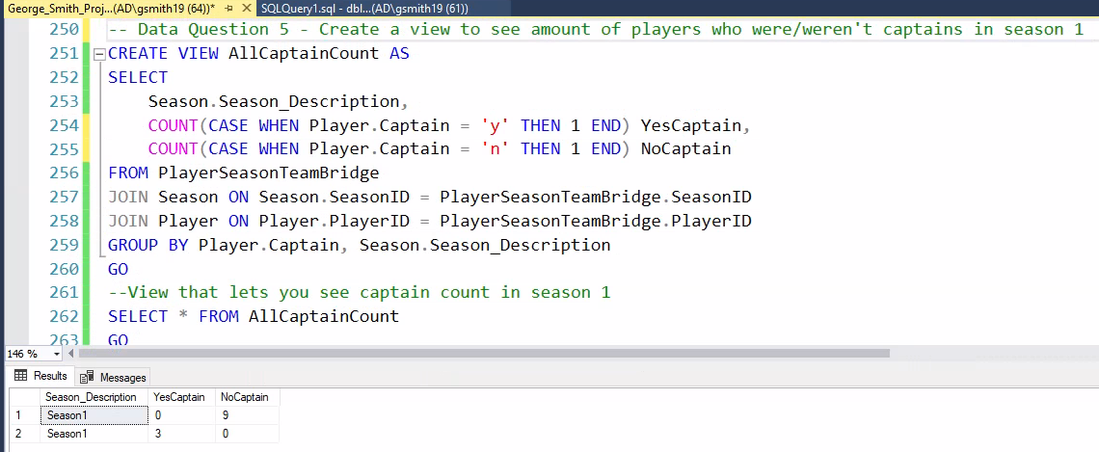

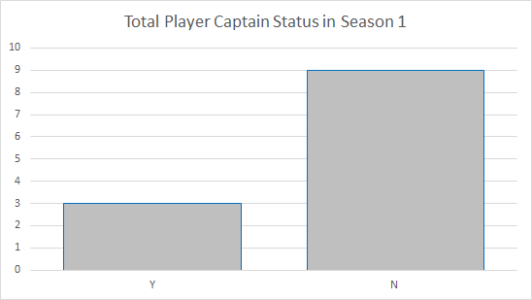

# **Report:**

I created a report using access that can look up a team's name and associated city by selecting either the coaches first or last name.

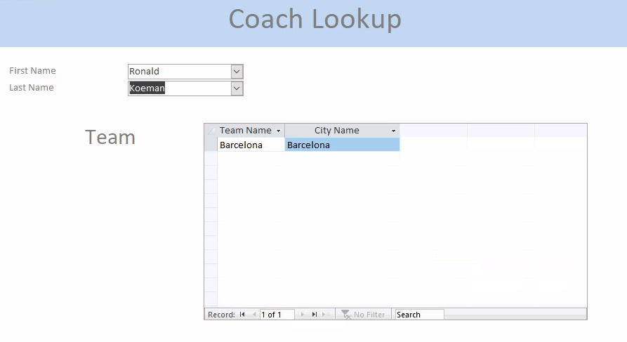

# 

# **Conceptual Model:**

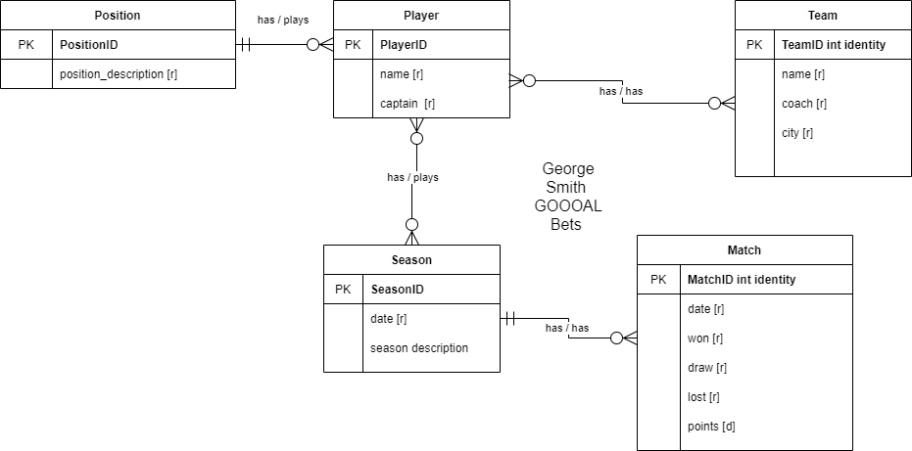**Logical Model:**

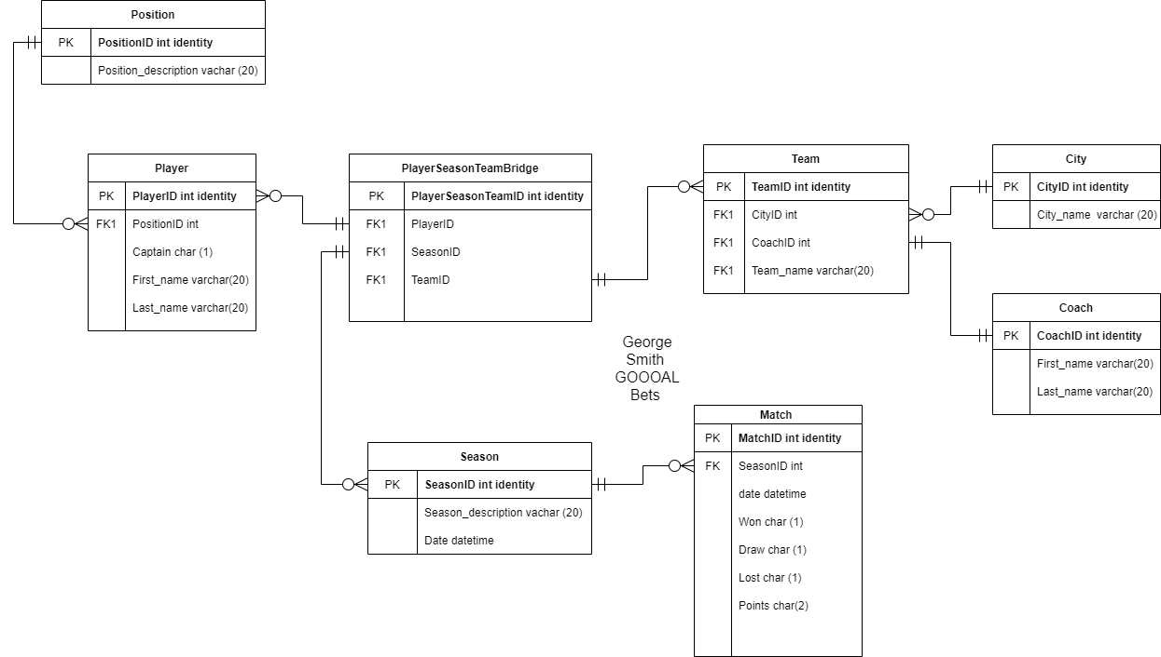

# **Raw Data Sample:**

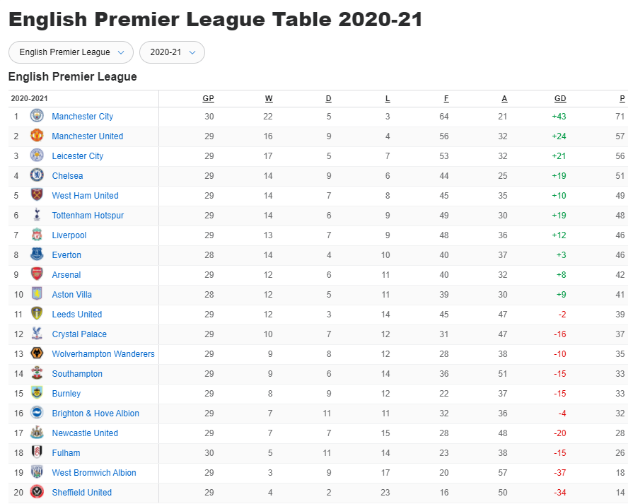

**Physical DataBase Design:**

/*

George Smith

Project

Course : IST659 M402

Term : January 2021

*/

--Drop Views

IF OBJECT_ID('PlayerPositionCount') IS NOT NULL

DROP VIEW PlayerPositionCount

IF OBJECT_ID('CityTeamCount') IS NOT NULL

DROP VIEW CityTeamCount

IF OBJECT_ID('TeamRosterCount') IS NOT NULL

DROP VIEW TeamRosterCount

IF OBJECT_ID ('TeamWins') IS NOT NULL

DROP VIEW TeamWins

IF OBJECT_ID ('AllCaptainCount') IS NOT NULL

DROP VIEW AllCaptainCount

IF OBJECT_ID ('CaptainCount') IS NOT NULL

DROP VIEW CaptainCount

-- Drop Procedures

IF OBJECT_ID ('UpdatePosition') IS NOT NULL

DROP PROCEDURE UpdatePosition

--Drop Tables

IF OBJECT_ID ('PlayerSeasonTeamBridge') IS NOT NULL

DROP TABLE PlayerSeasonTeamBridge

IF OBJECT_ID ('Player') IS NOT NULL

DROP TABLE Player

IF OBJECT_ID ('Contest') IS NOT NULL

DROP TABLE Contest

IF OBJECT_ID ('Team') IS NOT NULL

DROP TABLE Team

IF OBJECT_ID ('Season') IS NOT NULL

DROP TABLE Season

IF OBJECT_ID ('Position') IS NOT NULL

DROP TABLE Position

IF OBJECT_ID ('Coach') IS NOT NULL

DROP TABLE Coach

IF OBJECT_ID ('City') IS NOT NULL

DROP TABLE City

-- Create Table City

CREATE TABLE City (

-- Columns for City Table

CityID int identity,

City_Name varchar(20) not null

-- Constraints on City Table

CONSTRAINT PK_City PRIMARY KEY (CityID),

CONSTRAINT U1_Table UNIQUE (City_Name)

);

go

--End Creating the City Table

-- Create Table Coach

CREATE TABLE Coach (

--Columns for Coach Table

CoachID int identity,

First_Name varchar (20) not null,

Last_Name varchar(20) not null

-- Constraints on Coach Table

CONSTRAINT PK_Coach PRIMARY KEY (CoachID)

);

go

-- end create table Coach

-- Create table Season

CREATE TABLE Season (

--Columns for Season table

SeasonID int identity,

Season_Description varchar(20),

-- Constraints on Season Table

CONSTRAINT PK_Season PRIMARY KEY (SeasonID),

CONSTRAINT U1_Season UNIQUE (Season_Description)

);

go

-- End create Table season

-- Create Table Team

CREATE TABLE Team (

--Columns for the Team Table

TeamID int identity,

CityID int,

CoachID int,

Team_Name varchar(20)

--Constraints on Team Table

CONSTRAINT PK_Team PRIMARY KEY (TeamID)

CONSTRAINT FK1_Team FOREIGN KEY (CityID) REFERENCES City (CityID),

CONSTRAINT FK2_Team FOREIGN KEY (CoachID) REFERENCES Coach (CoachID),

);

go

-- End Creating the Team Table

-- Create Table Contest

CREATE TABLE Contest (

--Columns for the Contest Table

MatchID int identity,

HomeTeamID int,

AwayTeamID int,

SeasonID int,

MatchDate datetime,

Won char (1)

-- Consraints on Contest table

CONSTRAINT PK_Match PRIMARY KEY (MatchID),

CONSTRAINT FK1_Match FOREIGN KEY (HomeTeamID) REFERENCES Team (TeamID),

CONSTRAINT FK2_Match FOREIGN KEY (AwayTeamID) REFERENCES Team (TeamID),

CONSTRAINT FK3_Match FOREIGN KEY (SeasonID) REFERENCES Season (SeasonID)

);

go

--END Creating Table Contest

--Create Table Player

CREATE TABLE Player (

--Columns for Player table

PlayerID int identity,

Position varchar (20),

Captain Char (1),

First_Name varchar (20),

Last_Name varchar (20)

-- Create Constaints for Player Table

CONSTRAINT PK_Player PRIMARY KEY (PlayerID)

);

GO

--End Creating table Player

-- Create Table PlayerSeasonTeamBridge

CREATE TABLE PlayerSeasonTeamBridge (

--Columns for the Contest Table

PlayerSeasonTeamID int identity,

PlayerID int,

SeasonID int,

TeamID int,

--Constraints on PlayerSeasonTeamBridge

CONSTRAINT PK_PlayerSeasonTeamBridge PRIMARY KEY (PlayerSeasonTeamID),

CONSTRAINT FK1_PlayerSeasonTeamBridge FOREIGN KEY (PlayerID) REFERENCES Player (PlayerID),

CONSTRAINT FK2_PlayerSeasonTeamBridge FOREIGN KEY (SeasonID) REFERENCES Season (SeasonID),

CONSTRAINT FK3_PlayerSeasonTeamBRidge FOREIGN KEY (TeamID) REFERENCES Team (TeamID)

);

GO

--End Creating Table Player

-- Insert data into Player table

INSERT INTO Player (Position,Captain,First_Name,Last_Name)

VALUES

('Forward','Y','Lionel','Messi'),

('Midfield','N','Philippe','Coutimho'),

('Defense','N','Carles','Puyol'),

('Goalie','N','Marc-Andre','ter Stegen'),

('Forward','N','Karim','Benzema'),

('Forward','N','Eden', 'Hazard'),

('Midfield','N','Luka','Modric'),

('Defense','Y','Sergio','Ramos'),

('Goalie','N','Thibaut','Courtois'),

('Forward','N','Timo','Werner'),

('Midfield','Y','Christian','Pilisic'),

('Defense','N','Marcos','Alonso')

INSERT INTO City (City_Name)

VALUES

('Barcelona'),

('Madrid'),

('London')

INSERT INTO Coach (First_Name,Last_Name)

VALUES

('Ronald','Koeman'),

('Zinedine','Zidane'),

('Thomas','Tuchel')

INSERT INTO Team (CityID,CoachID,Team_Name)

VALUES

((SELECT CityID FROM City WHERE City_Name = 'Barcelona'), (SELECT CoachID FROM Coach WHERE First_Name = 'Ronald' AND Last_Name = 'Koeman'), 'Barcelona'),

((SELECT CityID FROM City Where City_Name = 'Madrid'), (SELECT CoachID FROM Coach WHERE First_Name = 'Zinedine' AND Last_Name = 'Zidane'), 'Real_Madrid'),

((SELECT CityID FROM City Where City_Name= 'London'), (SELECT CoachID FROM Coach WHERE First_Name = 'Thomas' AND Last_Name = 'Tucehl'), 'Chelsea')

INSERT INTO Season (Season_Description)

VALUES

('Season1'),

('Season2'),

('Season3')

INSERT INTO Contest (HomeTeamID, AwayTeamID, SeasonID, MatchDate, Won)

VALUES

((SELECT TeamID FROM Team WHERE Team_Name = 'Barcelona'), ( SELECT TeamID FROM Team WHERE Team_Name = 'Real_Madrid'), (SELECT SeasonID FROM Season Where Season_Description = 'Season1'), 1/1/2020, 'Y'),

(( SELECT TeamID FROM Team WHERE Team_Name = 'Barcelona'), ( SELECT TeamID FROM Team WHERE Team_Name = 'Chelsea'),(SELECT SeasonID FROM Season Where Season_Description = 'Season1'), 1/2/2020, 'Y'),

(( SELECT TeamID FROM Team WHERE Team_Name = 'Real_Madrid'), ( SELECT TeamID FROM Team WHERE Team_Name = 'Barcelona'),(SELECT SeasonID FROM Season Where Season_Description = 'Season1'), 1/3/2020, 'N'),

(( SELECT TeamID FROM Team WHERE Team_Name = 'Real_Madrid'), ( SELECT TeamID FROM Team WHERE Team_Name = 'Chelsea'),(SELECT SeasonID FROM Season Where Season_Description = 'Season1'), 1/4/2020, 'N'),

(( SELECT TeamID FROM Team WHERE Team_Name = 'Chelsea'), ( SELECT TeamID FROM Team WHERE Team_Name = 'Barcelona'),(SELECT SeasonID FROM Season Where Season_Description = 'Season1'), 1/5/2020, 'N'),

(( SELECT TeamID FROM Team WHERE Team_Name = 'Chelsea'), ( SELECT TeamID FROM Team WHERE Team_Name = 'Real_Madrid'),(SELECT SeasonID FROM Season Where Season_Description = 'Season1'), 1/6/2020, 'Y')

INSERT INTO PlayerSeasonTeamBridge (PlayerID,SeasonID,TeamID)

VALUES

((SELECT PlayerID FROM Player WHERE First_Name = 'Lionel'),(SELECT SeasonID FROM Season Where Season_Description = 'Season1'), (SELECT TeamID FROM Team WHERE Team_Name = 'Barcelona')),

((SELECT PlayerID FROM Player WHERE First_Name = 'Philippe'),(SELECT SeasonID FROM Season Where Season_Description = 'Season1'), (SELECT TeamID FROM Team WHERE Team_Name = 'Barcelona')),

((SELECT PlayerID FROM Player WHERE First_Name = 'Carles'),(SELECT SeasonID FROM Season Where Season_Description = 'Season1'), (SELECT TeamID FROM Team WHERE Team_Name = 'Barcelona')),

((SELECT PlayerID FROM Player WHERE First_Name = 'Marc-Andre'),(SELECT SeasonID FROM Season Where Season_Description = 'Season1'), (SELECT TeamID FROM Team WHERE Team_Name = 'Barcelona')),

((SELECT PlayerID FROM Player WHERE First_Name = 'Karim'),(SELECT SeasonID FROM Season Where Season_Description = 'Season1'), (SELECT TeamID FROM Team WHERE Team_Name = 'Real_Madrid')),

((SELECT PlayerID FROM Player WHERE First_Name = 'Eden'),(SELECT SeasonID FROM Season Where Season_Description = 'Season1'), (SELECT TeamID FROM Team WHERE Team_Name = 'Real_Madrid')),

((SELECT PlayerID FROM Player WHERE First_Name = 'Luka'),(SELECT SeasonID FROM Season Where Season_Description = 'Season1'), (SELECT TeamID FROM Team WHERE Team_Name = 'Real_Madrid')),

((SELECT PlayerID FROM Player WHERE First_Name = 'Sergio'),(SELECT SeasonID FROM Season Where Season_Description = 'Season1'), (SELECT TeamID FROM Team WHERE Team_Name = 'Real_Madrid')),

((SELECT PlayerID FROM Player WHERE First_Name = 'Thibaut'),(SELECT SeasonID FROM Season Where Season_Description = 'Season1'), (SELECT TeamID FROM Team WHERE Team_Name = 'Real_Madrid')),

((SELECT PlayerID FROM Player WHERE First_Name = 'Timo'),(SELECT SeasonID FROM Season Where Season_Description = 'Season1'), (SELECT TeamID FROM Team WHERE Team_Name = 'Chelsea')),

((SELECT PlayerID FROM Player WHERE First_Name = 'Christian'),(SELECT SeasonID FROM Season Where Season_Description = 'Season1'), (SELECT TeamID FROM Team WHERE Team_Name = 'Chelsea')),

((SELECT PlayerID FROM Player WHERE First_Name = 'Marcos'),(SELECT SeasonID FROM Season Where Season_Description = 'Season1'), (SELECT TeamID FROM Team WHERE Team_Name = 'Chelsea'))

GO

--Create a procedure to Update a players position when they decide it is time to make a change

CREATE PROCEDURE UpdatePosition (@First_Name varchar (20), @newPosition varchar(20))

AS

BEGIN

UPDATE Player SET Position = @newPosition

WHERE First_Name= First_Name

END

GO

-- Sample of how to use the Procedure to make Lionel Messi a goalie

--EXEC UpdatePosition 'lionel','goalie'

-- Data Question 1 - Create a view to see the amount of players at each position

CREATE VIEW PlayerPositionCount AS

SELECT

Position,

COUNT(First_Name) CountofPlayers

FROM Player

GROUP BY Position

GO

-- View Results

SELECT*FROM PlayerPositionCount

GO

-- Data Question 2 - Create a view to see how many teams each city has associated with them

CREATE VIEW CityTeamCount AS

SELECT

City.City_Name,

COUNT (Team.Team_Name) TeamCount

FROM City

JOIN Team on Team.CityID = City.CityID

GROUP BY City_Name, Team_Name

GO

-- View Results

SELECT * FROM CityTeamCount

GO

-- Data Question 3 -- What is the roster count for all teams

CREATE VIEW TeamRosterCount AS

SELECT

Team.Team_Name,

COUNT (PlayerSeasonTeamBridge.PlayerID) PlayerCount

FROM Team

JOIN PlayerSeasonTeamBridge on PlayerSeasonTeamBridge.TeamID = Team.TeamID

GROUP BY Team_Name

GO

--View Results

SELECT * FROM TeamRosterCount

GO

-- Data Question 4 - How many wins does each team have at home

CREATE VIEW TeamWins As

SELECT

Team.Team_Name,

COUNT(CASE WHEN Contest.Won = 'y' THEN 1 END) WinCount

FROM Team

JOIN Contest on Contest.HomeTeamID = Team.TeamID

GROUP BY Team_Name

GO

--View Results

SELECT * FROM TeamWins

GO

-- Data Question 5 - Create a view to see amount of players who were/weren't captains in season 1

CREATE VIEW AllCaptainCount AS

SELECT

Season.Season_Description,

COUNT(CASE WHEN Player.Captain = 'y' THEN 1 END) YesCaptain,

COUNT(CASE WHEN Player.Captain = 'n' THEN 1 END) NoCaptain

FROM PlayerSeasonTeamBridge

JOIN Season ON Season.SeasonID = PlayerSeasonTeamBridge.SeasonID

JOIN Player ON Player.PlayerID = PlayerSeasonTeamBridge.PlayerID

GROUP BY Player.Captain, Season.Season_Description

GO

--View that lets you see captain count in season 1

SELECT * FROM AllCaptainCount

GO

-- VIEW that lets you see all captains on Each Team

CREATE VIEW CaptainCount AS

SELECT

Team.Team_Name,

Season.Season_Description,

Player.Captain,

Player.First_Name,

Player.Last_Name

FROM PlayerSeasonTeamBridge

JOIN Team ON Team.TeamID = PlayerSeasonTeamBridge.TeamID

JOIN Season ON Season.SeasonID = PlayerSeasonTeamBridge.SeasonID

JOIN Player ON Player.PlayerID = PlayerSeasonTeamBridge.PlayerID

GROUP BY Player.Captain,Team.Team_Name, Season.Season_Description, Player.First_Name, Player.Last_Name

GO

SELECT * FROM CaptainCount

GO

**Reflection:**

At the start of this class I had only heard of the terms logical model, conceptual model, and SQL. My first assumption was that these models look simple enough to create and understand. I quickly learned that these diagrams require tons of planning and can be extremely difficult to to create. I was very intimidated when he came time to write code in SQL, as I have minimal coding experience. I found this portion of the class to be very enjoyable, and I feel that the SQL syntax is very logical. I look forward to learning how SQL is used in a business environment when data is being used in enormous quantities.

**Summary:**

A good logical model is absolutely necessary for creating a database. This is something I continued to refine throughout the project. I was able to create views while using select statements to answer all of my data questions. I created bar charts using R to generate bar data visualizations for each of my data questions. I created a form in access that can lookup a coaches team and the associated city by selecting either their first or last name.